

**C.K. Pithawalla College of Commerce-Management-Computer Application, Surat,Gujarat**

VEER NARMAD SOUTH GUJARAT UNIVERSITY, SURAT

Project Report On

**Payroll Management System**

AS A PARTIAL REQUIREMENT FOR THE DEGREE OF

BACHELOR OF COMPUTER APPLICATION

(B.C.A)

**2024-2025**

GUIDED BY : SUBMITTED BY :

**Prof. Gaurang Joshi** **VISHWAKARMA ABHISHEK RAMVRIKSH**

**DUBEY VISHAL JAYKUMAR**

**VASAVA CHIRAG** **RUDESH**

**Acknowledgement**

The reason of completing the project work successfully is not just our efforts but efforts of many people. The people, who trusted, guided and encouraged us with every means. Guide is a person who provides you the direction towards success, so we feel great pleasure to express our gratitude to all our guides, our faculty members as well as every person who helped me directly or indirectly with our project.

We would like to thank **Dr. Marteen Patel** (In-charge Principal at C.K.Pithawalla College)and **Mr. Gaurang Joshi** (BCA-HOD at C.K.Pithawalla College)for granting us an opportunity to work on this project. Their skills and experience was a guiding path in this learning process. She made constant efforts to shape up our skills as per the industry Standards. She provided us a very homely and friendly environment which made it the best place to work. Their guidance was really priceless and will always be a guiding light in Industry.

We are also indebted to our Professor **Mr. Gaurang Joshi** who provided constant encouragement, support & valuable guidance before and during our project. It was her effort who led us to this place for project work. Her guidance and suggestions were invaluable.

Thank you very much

**VISHWAKARMA ABHISHEK RAMVRIKSH**

**DUBEY VISHAL JAYKUMAR**

**VASAVA CHIRAG RUDESH**

|  |  |  |  |
| --- | --- | --- | --- |
| Index | | | |
| SrNo | **Chapter** | | **Page No** |
| 1 | **Introduction** | | **1** |
|  | 1.1 | Project Profile | 2 |
|  | 1.2 | Project Introduction | 3 |
| 2 | **Environment Description** | | **4** |
|  | 2.1 | Hardware Software Requirement | 5 |
|  | 2.2 | Tools And Technology | 6 |
| 3 | **Existing System** | | **10** |
|  | 3.1 Introduction | | 11 |
|  | 3.2 Limitation | | 12 |
| 4 | **Proposed System** | | **13** |
|  | 4.1 | Scope | 14 |
|  | 4.2 | Aim And Objective | 18 |
|  | 4.3 | Excepted Advantage | 20 |
| 5 | **System Planning** | | **23** |
|  | 5.1 | Requirement Specification | 24 |
|  | 5.2 | Feasibility Study (technical, Economy, and operational) | 28 |
|  | 5.3 | Life Cycle Model | 29 |
|  | 5.4 | Effort Distribution | 30 |
|  | 5.5 | Task Dependency Diagram | 31 |
|  | 5.6 | Project Schedule Chart (Time Line Chart ) | 32 |
| 6 | **System Model Architecture** | | **33** |
|  | 6.1 | Use Case Diagram | 34 |
|  | 6.2 | Activity Diagram | 35 |
| 7 | **System Diagram** | | **37** |
|  | 7.1 | Navigation Map (Site Map Diagram) | 38 |
|  | 7.2 | Database Diagram (Table Relationship Diagram) | 40 |
|  | 7.3 | Table Structure | 42 |
|  | 7.4 | Screen Layout | 45 |
| 8 | **System Testing** | | **50** |
|  | 8.1 | Testing Introduction | 51 |
|  | 8.2 | Test Case | 52 |
| 9 | **System Limitation And Future Enhancement** | | **53** |
| 10 | **References** | | **57** |
|  | 10.1 | Bibliography | 58 |
|  | 10.2 | Webography | 59 |

**1**

Chapter

**Introduction**

|  |  |
| --- | --- |
| 1.1 | Project Profile |
| 1.2 | Project Introduction |

**1.1 Project Profile**

|  |  |
| --- | --- |
| Project Title : | Payroll Management System |
| Objective : | To automate and ensure accurate, timely salary processing while maintaining compliance and reducing administrative effort. |
| Name of the institute : | C.K. Pithawala College Of Commerce Management & Computer Application |
| Developed For : | To automate accurate, timely salary processing. |
| Project Guide : | Mr. Gaurang Joshi |
| Front End : | HTML5, CSS3, JAVASCRIPT |
| Back End : | MySQL, PHP |
| Team Members : | 03 |

**1.2 Project Profile**

* Designed to automate and simplify payroll management.
* Ensures accurate salary calculations, tax deductions, and compliance with legal regulations.
* Eliminates manual processes, reducing errors and saving time.
* Streamlines tasks such as salary computation, payslip generation, and tax handling.
* Provides robust reporting features and secure storage of payroll and employee records.
* Facilitates comprehensive employee management by maintaining detailed employee records, including personal information, job details, salary structure, and performance history.
* Tracks employee attendance, integrating this data into payroll calculations to ensure accurate payouts.
* Enhances transparency and allows easy access to both payroll and employee information.
* Provides employee self-service features for accessing payslips, updating personal details, and viewing erning balances.
* Improves productivity and ensures timely salary disbursements to employees.
* Offers better workforce management with integrated employee data for HR tasks such as appraisals, and attendance tracking.
* Strengthens compliance with labor laws and company policies by maintaining detailed employee history and records for audits and reviews.

**2**

Chapter

**Environment Description**

|  |  |
| --- | --- |
| 2.1 : | Hardware and Software Requirements |
|  | 2.1.1 Development Tools |
|  | 2.1.2 Client Side Tool |
|  | 2.1.3 Server Side Tool |
| 2.2 : | **Tools and Technology** |
|  | 2.2.1 Core Technology |
|  | 2.2.2 Extra Tools |
|  |  |

2.1 Hardware And Software Requiments

* Client Side :
* Internet enabled device with web Brower
* Server Side :
* Xampp Server (3.3.0 Version)
* Disk Space (4GB)
* Development Side :
* Processor ( intel i5 or higher )
* O.S (Windows 8.1 or higher)
* Memory (4GB)
* Hard Disk (500GB)
* Web Brower : Developed in Google Chrome (Tested in Google Chrome)

2.2 Tools And Technology

**Technology:**

* **Core Technology** :
* **HTML:**

**-** First developed by Tim Berners-Lee in 1990, **HTML** is short for Hypertext Markup Language.

**- HTML** is used to create electronic documents (called pages) that are displayed on the World Wide Web.

**-** Each page contains a series of connections to other pages called hyperlinks.

* **MySQL:**

**- MySQL**, the most popular Open Source SQL database management system, is developed, distributed, and supported by Oracle Corporation.

**-** The **MySQL** website (http://www.**mysql**.com/) provides the latest **information about MySQL** software.

**-** A database is a structured collection of data.

* **PHP:**

**-** Hypertext Preprocessor (or simply **PHP**) is a general-purpose programming language was 32-bit x86 builds, requiring Windows 32-bit compatibility mode while using **Internet** **Information** **Services** (IIS) on a 64-bit Windows platform.

* **Extra Technology:**
* **JQuery:**

**- JQuery** is a JavaScript library designed to simplify HTML DOM tree traversal and manipulation, as well as event handling, CSS animation, and Ajax.

**- JQuery** also provides capabilities for developers to create plug-ins on top of the JavaScript library.

* **CSS:**

**-** **CSS** is a stylesheet language used to describe the presentation of HTML or XML documents**.**

**-** **CSS** controls layout, colors, fonts, and overall design, separating content from presentation.

**-** **A CSS** rule consists of a selector and declaration block.

**-A** declaration block contains properties and values

**-** **Control** how elements are placed with static, relative, absolute, fixed, and sticky positioning.

**-** **Enable** animations and smooth style changes using CSS transitions and keyframes.

* **JavaScript:**

**- JavaScript** is a dynamic computer programming language.

**-** It is lightweight and most commonly used as a part of web pages, whose implementations allow client-side script to interact with the user and make dynamic pages.

**-** It is an interpreted programming language with object-oriented capabilities.

**Tools:**

* **Documentation Tools:**
* **EDraw:**

**- Edraw** Max is a 2D business technical diagramming software which help create flowcharts, organizational charts, mind map, network diagrams, floor plans, workflow diagrams, business charts, and engineering diagrams.

**-** **Edraw** Max gives users a Visio-like, professional quality diagramming tool.

* **MS Word:**

**- Microsoft Word** or **MS**-**WORD** (often called **Word**) is a Graphical **word** processing program that users can type with.

**-** It is made by the computer company **Microsoft**. Its purpose is to allow users to type and save documents.

* **MS Power Point:**

**- PowerPoint** is a slideshow presentation program that's part of the **Microsoft** office suite of tools.

**-PowerPoint** makes it easy to create, collaborate, and present your ideas in dynamic, visually compelling ways.

* **Development Tools:**

Sublime Text 3

* **Sublime Text 3:**

**- Sublime Text 3** is an amazing piece of software.

**-** To start, it is a clean, functional, and fast code editor.

**-** Not only does it have incredible built in features (multi-edit and vim mode), but it has support for plugins, snippets, and many other things.

**3**

Chapter

**Existing System**

|  |  |
| --- | --- |
| 3.1 : | Introduction |
| 3.2 : | **Limitation** |
|  |  |
|  |  |
|  |  |

3.1 Introduction

A **Payroll Management System** is a software solution designed to automate, streamline, and simplify the process of managing employee compensation. It handles various payroll tasks, such as calculating salaries, withholding taxes, and distributing payments, ensuring that employees are paid accurately and on time.

**Key Features:**

1. **Salary Calculation**: Automates the computation of employee wages based on hours worked, overtime, bonuses, and deductions.
2. **Tax Management**: Handles tax deductions and ensures compliance with local, state, and national tax regulations.
3. **Employee Database**: Stores employee records, including salary structure, tax details, and attendance information.
4. **Attendance Management**: Tracks leave balances, employee attendance, and integrates with payroll to adjust for absences.
5. **Payslip Generation**: Creates and distributes detailed payslips with salary breakdowns and deductions.
6. **Compliance and Reporting**: Ensures adherence to labor laws and generates reports for auditing and financial purposes.

**Benefits:**

* **Time and Cost Efficiency**: Reduces manual efforts and human errors.
* **Accuracy**: Automates complex calculations and ensures error-free payroll processing.
* **Data Security**: Safeguards sensitive employee and salary information with encryption and access controls.

3.2 Limitations

* **Initial Setup Complexity**: Configuring a payroll system to meet the specific requirements of a company, such as tax rules, employee benefits, and salary structures, can be time-consuming and complex.
* **Cost of Implementation**: High-quality payroll software can be expensive, especially for small businesses. Costs may include software licenses, updates, and employee training.
* **Customization Limitations**: Some payroll systems may not offer flexibility for companies with unique payroll structures or policies, limiting the ability to customize the system fully.
* **Technical Issues**: Payroll software may experience bugs, downtime, or data loss, which can disrupt the payroll process and delay employee payments.
* **Data Security Risks**: Storing sensitive information, such as employee salaries and tax details, on a digital platform can make it vulnerable to hacking, unless strong security measures are in place.
* **Integration Challenges**: Integrating payroll systems with other HR or financial software can be difficult, leading to data inconsistencies or incomplete workflows.
* **Regulatory Changes**: Payroll systems may need regular updates to stay compliant with tax laws and labor regulations. Failing to update the system can result in penalties or legal issues.
* **User Training**: Employees, particularly HR staff, may need comprehensive training to use the system effectively, which adds to the overall time and cost of implementation.
* **Limited Scalability**: Some payroll systems may not easily scale as a business grows, requiring migration to a new system if the company outgrows the initial software.
* **Dependence on Internet Connectivity**: Cloud-based payroll systems rely on a stable internet connection. Any connectivity issues can hinder access to payroll data and delay the process.

**4**

Chapter

**Proposed System**

|  |  |
| --- | --- |
|  | 4.1 Scope  4.2 Aim and Objective  4.3 Excepted Advantage |

4.1 Scope

Here’s a detailed scope of a **Payroll Management System** from both the **admin** and **employee** perspectives:

**Admin Side (HR/Payroll Manager)**

1. **Dashboard and Analytics**
   * Overview of payroll summaries, notifications, and alerts.
   * Access to detailed reports and analytics for payroll, attendance, and compliance.
2. **Employee Management**
   * Add, update, or remove employee records.
   * Manage employee details such as personal information, job positions, and salary structures.
   * Handle employee onboarding and offboarding processes.
3. **Payroll Processing**
   * Configure and run payroll cycles (e.g., monthly, bi-weekly).
   * Calculate salaries, bonuses, overtime, and deductions.
   * Process payroll adjustments and corrections.
4. **Tax Management**
   * Set up and update tax rules and brackets.
   * Calculate and withhold taxes according to legal requirements.
   * Generate and submit tax forms (e.g., W-2s, 1099s) to relevant authorities.
5. **Attendance Management**
   * Track and approve employee leave requests.
   * Monitor attendance and integrate data with payroll for accurate deductions and adjustments.
6. **Benefits Administration**
   * Manage employee benefits such as health insurance, retirement plans, and other perks.
   * Handle automatic deductions for benefits and track contributions.
7. **Reporting**
   * Generate and review detailed payroll reports, including payroll summaries, tax reports, and benefit summaries.
   * Create custom reports based on specific criteria or needs.
8. **Compliance and Legal**
   * Ensure compliance with labor laws, tax regulations, and company policies.
   * Keep the system updated with changes in legal requirements and regulations.
9. **Integration and Configuration**
   * Integrate with other systems such as HRMS, accounting, and time tracking software.
   * Configure system settings, payroll rules, and user permissions.
10. **Security and Data Management**
    * Manage user roles and permissions to control access to sensitive data.
    * Implement security measures to protect payroll information from unauthorized access.
11. **Audit and Tracking**
    * Maintain an audit trail of payroll activities and changes.
    * Monitor system logs and track discrepancies or issues.

**Employee Side**

1. **Personal Dashboard**
   * Access personal payroll information, including salary, deductions, and benefits.
   * View and manage personal details such as contact information and bank accounts.
2. **Payslip Access**
   * View, download, and print payslips.
   * Review salary breakdown, tax deductions, and net pay details.
3. **Leave and Attendance**
   * Request leave and view leave balances.
   * Track attendance records and history.
4. **Tax Information**
   * Access tax-related documents and summaries.
   * Update tax withholding preferences and personal tax information.
5. **Benefits Management**
   * Review and manage benefits selections (e.g., health insurance, retirement plans).
   * Make changes or enroll in new benefits programs.
6. **Self-Service Requests**
   * Submit requests for salary advances or other payroll-related adjustments.
   * Communicate with HR or payroll departments for issues or clarifications.
7. **Historical Data Access**
   * View historical payroll data, including past payslips and tax documents.
8. **Security and Privacy**
   * Securely access personal payroll information through user authentication.
   * Ensure privacy and confidentiality of personal data.

**Conclusion**

The scope of a payroll management system encompasses comprehensive functionalities for both admins and employees. For admins, it includes managing payroll processing, compliance, benefits, and reporting. For employees, it offers self-service features to access and manage personal payroll information, benefits, and leave requests. Both sides work together to ensure accurate, efficient, and compliant payroll management.

4.2 Aim and Objective

**Aim**

The primary aim of a Payroll Management System is to automate and streamline the payroll process to ensure accurate, timely, and efficient processing of employee compensation, while maintaining compliance with legal and organizational requirements.

**Objectives**

1. **Automate Payroll Processing**
   * To reduce manual effort and errors by automating salary calculations, deductions, and payroll runs.
   * To ensure timely and accurate disbursement of salaries and benefits.
2. **Ensure Compliance**
   * To comply with local, state, and national tax regulations and labor laws.
   * To keep up-to-date with regulatory changes and ensure adherence to legal requirements.
3. **Enhance Accuracy**
   * To minimize errors in payroll processing through automated calculations and data integration.
   * To provide accurate payslips and financial records for employees and the organization.
4. **Manage Employee Records**
   * To maintain a centralized and up-to-date database of employee information, including salary details, tax information, and benefits.
   * To streamline employee onboarding and offboarding processes.
5. **Facilitate Reporting and Analytics**
   * To generate comprehensive payroll reports and analytics for financial planning, auditing, and compliance purposes.
   * To provide insights into payroll costs, tax liabilities, and employee benefits.
6. **Improve Efficiency**
   * To optimize payroll processing time and reduce administrative overhead by automating routine tasks.
   * To integrate seamlessly with other systems such as HR, accounting, and attendance systems.
7. **Provide Self-Service Capabilities**
   * To enable employees to access and manage their payroll information, payslips, and benefits through a self-service portal.
   * To empower employees to track their attendance, leave, and tax details independently.
8. **Enhance Data Security**
   * To protect sensitive payroll information from unauthorized access through robust security measures and user permissions.
   * To ensure data privacy and compliance with data protection regulations.
9. **Enable Accurate Tax Management**
   * To automate tax calculations, withholdings, and reporting to ensure compliance and avoid penalties.

**Conclusion**

The Payroll Management System aims to streamline and automate payroll processes to improve accuracy, efficiency, and compliance. Its objectives focus on reducing manual efforts, ensuring legal adherence, managing employee records, providing self-service options, and maintaining data security. Through these objectives, the system supports accurate and timely payroll processing while meeting the needs of both the organization and its employees.

4.2 Expected Advantages

**1. Improved Accuracy**

* **Automated Calculations**: Reduces errors in salary computations, deductions, and tax withholdings.
* **Consistent Data**: Ensures uniformity and accuracy in payroll data across all employees.

**2. Time and Cost Efficiency**

* **Reduced Manual Work**: Automates routine tasks such as payroll processing, reducing administrative time and effort.
* **Lower Administrative Costs**: Minimizes the need for extensive manual payroll management and paperwork.

**3. Timely Payroll Processing**

* **On-Time Payments**: Ensures employees are paid accurately and on time, improving employee satisfaction.
* **Efficient Processing**: Streamlines payroll runs, allowing for faster processing and adjustments.

**4. Enhanced Compliance**

* **Regulatory Adherence**: Helps in meeting legal requirements and tax obligations by automating compliance processes.
* **Up-to-Date Tax Management**: Keeps the system updated with changes in tax laws and regulations.

**5. Better Data Security**

* **Protected Information**: Safeguards sensitive payroll data with secure access controls and encryption.
* **Reduced Risk of Fraud**: Minimizes the risk of unauthorized access and fraud through controlled user permissions.

**6. Comprehensive Reporting**

* **Detailed Reports**: Provides access to a variety of reports, such as payroll summaries, tax reports, and benefit statements.
* **Data Analytics**: Offers insights into payroll costs, trends, and other critical financial data.

**7. Employee Self-Service**

* **Access to Information**: Allows employees to view and manage their own payroll information, payslips, and leave records.
* **Reduced HR Workload**: Decreases the number of inquiries and requests handled by HR staff.

**8. Simplified Benefits Administration**

* **Easy Management**: Facilitates the management of employee benefits, including insurance and retirement plans.
* **Automated Deductions**: Handles automatic deductions for benefits and contributions.

**9. Scalability**

* **Adaptable System**: Supports business growth by accommodating additional employees and changes in payroll policies.
* **Flexible Integration**: Easily integrates with other HR and financial systems as the organization expands.

**10. Improved Accuracy in Tax Management**

* **Automated Tax Calculations**: Ensures correct withholding and reporting of taxes.
* **Efficient Tax Filing**: Facilitates the generation and submission of tax forms and reports.

**11. Enhanced Employee Satisfaction**

* **Transparent Processes**: Provides employees with clear and accurate information about their compensation and deductions.
* **Reduced Errors**: Fewer payroll errors lead to higher trust and satisfaction among employees.

**12. Audit Trail and Compliance**

* **Complete Record Keeping**: Maintains a detailed audit trail of all payroll transactions and changes.
* **Ease of Audits**: Simplifies internal and external audits by providing accurate and accessible payroll data.

**5**

Chapter

**System Planning**

|  |  |
| --- | --- |
| 5.1 | Requirement Specification |
| 5.2 | Feasibility Study |
| 5.3 | Life Cycle Model |
| 5.4 | Effort Distribution Diagram |
| 5.5 | Task Dependency Diagram |
| 5.6 | Project Schedule Chart |

5.1 **Requirement Specification**

Here’s a detailed outline for the **requirement specification** of a Payroll Management System:

**1. Functional Requirements**

**1.1 Employee Management**

* **Employee Records**: Ability to add, update, and maintain employee information (e.g., personal details, job position, salary structure).
* **Onboarding and Offboarding**: Features for managing new hires, terminations, and transfers.

**1.2 Payroll Processing**

* **Salary Calculation**: Automated calculation of salaries, overtime, bonuses, and deductions based on predefined rules.
* **Payroll Runs**: Support for different payroll cycles (e.g., monthly, bi-weekly, weekly).
* **Adjustments**: Capability to process adjustments and corrections in payroll.

**1.3 Tax Management**

* **Tax Calculations**: Automated calculation and withholding of taxes (e.g., income tax, social security).
* **Tax Reporting**: Generation of tax forms and reports (e.g., W-2, 1099).

**1.4 Leave and Attendance Management**

* **Leave Requests**: Feature to request, approve, and track leave.
* **Attendance Tracking**: Integration with attendance systems or manual entry for tracking employee hours and absences.

**1.5 Benefits Administration**

* **Benefits Management**: Administration of employee benefits (e.g., health insurance, retirement plans).
* **Deductions**: Automatic calculation and deduction for benefits.

**1.6 Reporting and Analytics**

* **Payroll Reports**: Generation of detailed reports (e.g., payroll summaries, tax reports, benefits reports).
* **Custom Reports**: Ability to create and export custom reports based on various criteria.

**1.7 Self-Service Portal**

* **Employee Access**: Secure portal for employees to view payslips, manage personal details, and request leave.
* **Self-Service Features**: Allow employees to update tax information and benefits selections.

**1.8 Compliance and Security**

* **Regulatory Compliance**: Ensure adherence to local, state, and national regulations.
* **Data Security**: Implement security measures to protect sensitive payroll data, including encryption and access controls.

**2. Non-Functional Requirements**

**2.1 Usability**

* **User Interface**: Intuitive and user-friendly interface for both administrators and employees.
* **Accessibility**: Accessible design that supports various devices and screen sizes.

**2.2 Performance**

* **Processing Speed**: Efficient handling of payroll calculations and data processing.
* **Scalability**: Ability to handle increasing numbers of employees and payroll transactions.

**2.3 Reliability**

* **System Availability**: High availability with minimal downtime.
* **Error Handling**: Robust error detection and handling mechanisms.

**2.4 Integration**

* **HR and Accounting Systems**: Integration with existing HR and accounting software for seamless data flow.
* **Third-Party Services**: Support for integration with third-party services such as tax authorities or benefits providers.

**2.5 Data Management**

* **Backup and Recovery**: Regular data backups and recovery options to prevent data loss.
* **Data Integrity**: Ensuring data accuracy and consistency.

**2.6 Compliance**

* **Legal and Regulatory Compliance**: Adherence to data protection regulations and labor laws (e.g., GDPR, HIPAA).
* **Audit Trail**: Maintain detailed logs of payroll activities and changes for auditing purposes.

**3. Technical Requirements**

**3.1 Software Requirements**

* **Operating System**: Compatibility with major operating systems (e.g., Windows, Linux).
* **Web Browser**: Support for common web browsers (e.g., Chrome, Firefox, Safari).

**3.2 Hardware Requirements**

* **Server Specifications**: Adequate server resources (e.g., CPU, RAM, storage) for handling payroll operations.
* **Client Devices**: Support for various client devices, including desktops, laptops, and mobile devices.

**3.3 Security Specifications**

* **Authentication**: Secure login and authentication mechanisms.
* **Authorization**: Role-based access controls to restrict access to sensitive data.

**4. Implementation and Support**

**4.1 Installation and Deployment**

* **Installation**: Guidelines for software installation and configuration.
* **Deployment**: Steps for deploying the system in a live environment.

**4.2 Training and Documentation**

* **User Training**: Training programs for administrators and employees on system usage.
* **Documentation**: Comprehensive user manuals, system documentation, and help resources.

**4.3 Maintenance and Support**

* **Support Services**: Access to technical support for troubleshooting and issue resolution.
* **Updates and Upgrades**: Regular updates and upgrades to enhance system functionality and security.

5.2 Feasibility Study

**Feasibility study is an online description of the Website and how it will be used.**

**Three test of feasibility studies by us:**

**1) Technical Feasibility.**

**2) Economical Feasibility.**

**3) Operational feasibility.**

**1) Technical Feasibility**

* Technical feasibility is concerned with technical facilities and tools available and their relation with Website.
* The Website has been developed with Wamp server 3.3.0 and Mysql as backend tools and for the designing use the jquery and cascading style sheet (css).
* We need proper knowledge of technology and its functional areas.

**2) Economical Feasibility**

* Economical feasibility looks at the financial aspects of the investment in a project.
* Form the financial point of view the project is feasible; we guess there will not be any monetary requirement for our project.

**3) Operational Feasibility**

* Test of operational feasibility asks if the application will work when it is developed and installed.
* As well as this application do not cause any harm to the other application, and can also be implemented in-phase with the other application.
* System provides the user friendly interface which helps new user in operating the application.

5.3 Life Cycle Model

* **Increment Model:**
* The incremental Model is an evolution of the waterfall Model, where the waterfall Model is incrementally applied.
* The series of releases is referred to as “increments”, with each increment providing more functionality to the customers. After the first increment, a core product is delivered, which can already be used by the customer. Based on customer feedback, a plan is developed for the next increments, and modifications are made accordingly. This process continues, with increments being delivered until the complete product is delivered. The incremental philosophy is also used in the agile process model.
  + - **Advantages**
* After every iteration any faulty piece software can be identified easily as very few changes are done after every iteration.
* It is easier to test and debug as testing and debugging can be performed after each iteration.
* This model does not affect anyone's business values because they provide core of the software which customer needs, which will indeed help that person to keep run his business.
* After establishing an overall architecture, system is developed and delivered in increments.
  + - **Disadvantages**
* If the requirements initially were thought to be stable but at later stages are realized to be unstable then the increments have to be withdrawn and have to be reworked.
* Resulting cost may exceed the cost of the organization. Problems may arise related to system architecture.

5.4 Effort Distribution Diagram

An **Effort Distribution Diagram** is a graphical representation used to show how effort or resources are distributed across different phases, tasks, or components of a project. It helps in visualizing the allocation of time, effort, or cost, and is useful for project planning, management, and monitoring.

|  |  |
| --- | --- |
| Project Planning: | 2 to 3 % |
| Requirement Analysis: | 10 to 25 % |
| Design: | 20 to 25 % |
| Coding: | 15 to 20 % |
| Testing / Debugging: | 30 to 40 % |

5.5 Task Dependency Diagram

**Requirement Analysis**

**Planning & Risk Analysis**

**Designing**

**Coding & Integrating Module**

**Testing**

**Requirement Gathering**

**Analyze Gathered Information**

**Determine Scope of the** System

5.6 Project Schedule Chart

* The time line chart describes the time scheduling for project completion
* This time line chart shows project tasks in weekly schedule.

|  |  |  |  |  |  |  |  |  |  |  |  |  |  |  |
| --- | --- | --- | --- | --- | --- | --- | --- | --- | --- | --- | --- | --- | --- | --- |
| **Task** | **Month 1** | | | | | | **Month 2** | | | | **Month 3** | | | |
|  | **W1** | | **W2** | | **W3** | **W4** | **W1** | **W2** | **W3** | **W4** | **W**  **1** | **W**  **2** | **W**  **3** | **W**  **4** |
| 1. **Requirement Gathering** |  | |  |  | |  |  |  |  |  |  |  |  |  |
| Collected Details from developed sites |  |  | |  | |  |  |  |  |  |  |  |  |  |
| Analyzed gathered information |  |  | |  | |  |  |  |  |  |  |  |  |  |
| Determine the scope of the system |  |  | |  | |  |  |  |  |  |  |  |  |  |
| Milestone**:**Req. gathering completed. |  |  | |  | |  |  |  |  |  |  |  |  |  |
| 1. **Planning** |  |  | |  | |  |  |  |  |  |  |  |  |  |
| Basic flow and structure |  |  | |  | |  |  |  |  |  |  |  |  |  |
| Determined different modules |  |  | |  | |  |  |  |  |  |  |  |  |  |
| Milestone: Planning completed |  |  | |  | |  |  |  |  |  |  |  |  |  |
| 1. **Designing** |  |  | |  | |  |  |  |  |  |  |  |  |  |
| Basic Interface design |  |  | |  | |  |  |  |  |  |  |  |  |  |
| Database Design |  |  | |  | |  |  |  |  |  |  |  |  |  |
| Design web forms and modules |  |  | |  | |  |  |  |  |  |  |  |  |  |
| Milestone: Designing Completed |  |  | |  | |  |  |  |  |  |  |  |  |  |
| 1. **Risk Analysis** |  |  | |  | |  |  |  |  |  |  |  |  |  |
| Milestone: Risk Analysis Completed |  |  | |  | |  |  |  |  |  |  |  |  |  |
| 1. **Coding and Integrating modules** |  |  | |  | |  |  |  |  |  |  |  |  |  |
| Implement logic for diff modules |  |  | |  | |  |  |  |  |  |  |  |  |  |
| Integrating code with backend |  |  | |  | |  |  |  |  |  |  |  |  |  |
| Integrating dependent modules |  |  | |  | |  |  |  |  |  |  |  |  |  |
| Milestone: Coding completed |  |  | |  | |  |  |  |  |  |  |  |  |  |
| 1. **Testing of developed system** |  |  | |  | |  |  |  |  |  |  |  |  |  |
| Milestone: Finalized |  |  | |  | |  |  |  |  |  |  |  |  |  |
| 1. **Documentation** |  |  | |  | |  |  |  |  |  |  |  |  |  |
| Milestone: Documentation completed |  |  | |  | |  |  |  |  |  |  |  |  |  |

**6**

Chapter

**System Model Architecture**

|  |  |
| --- | --- |
| 6.1 | Use Case Diagram |
| 6.2 | Activity Diagram |
|  |  |

6.1 Use Case Digram

* **Super Admin’s Use Case Diagram:**

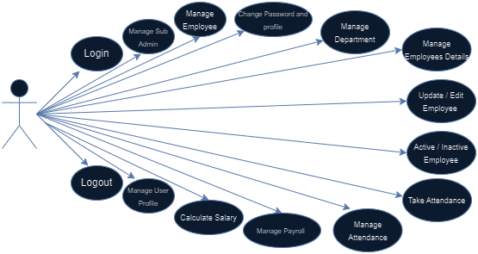

* **Employee’s Use Case Diagram:**

# 

6.2 Activity Digram

* **Activity Diagram for Super Admin:**

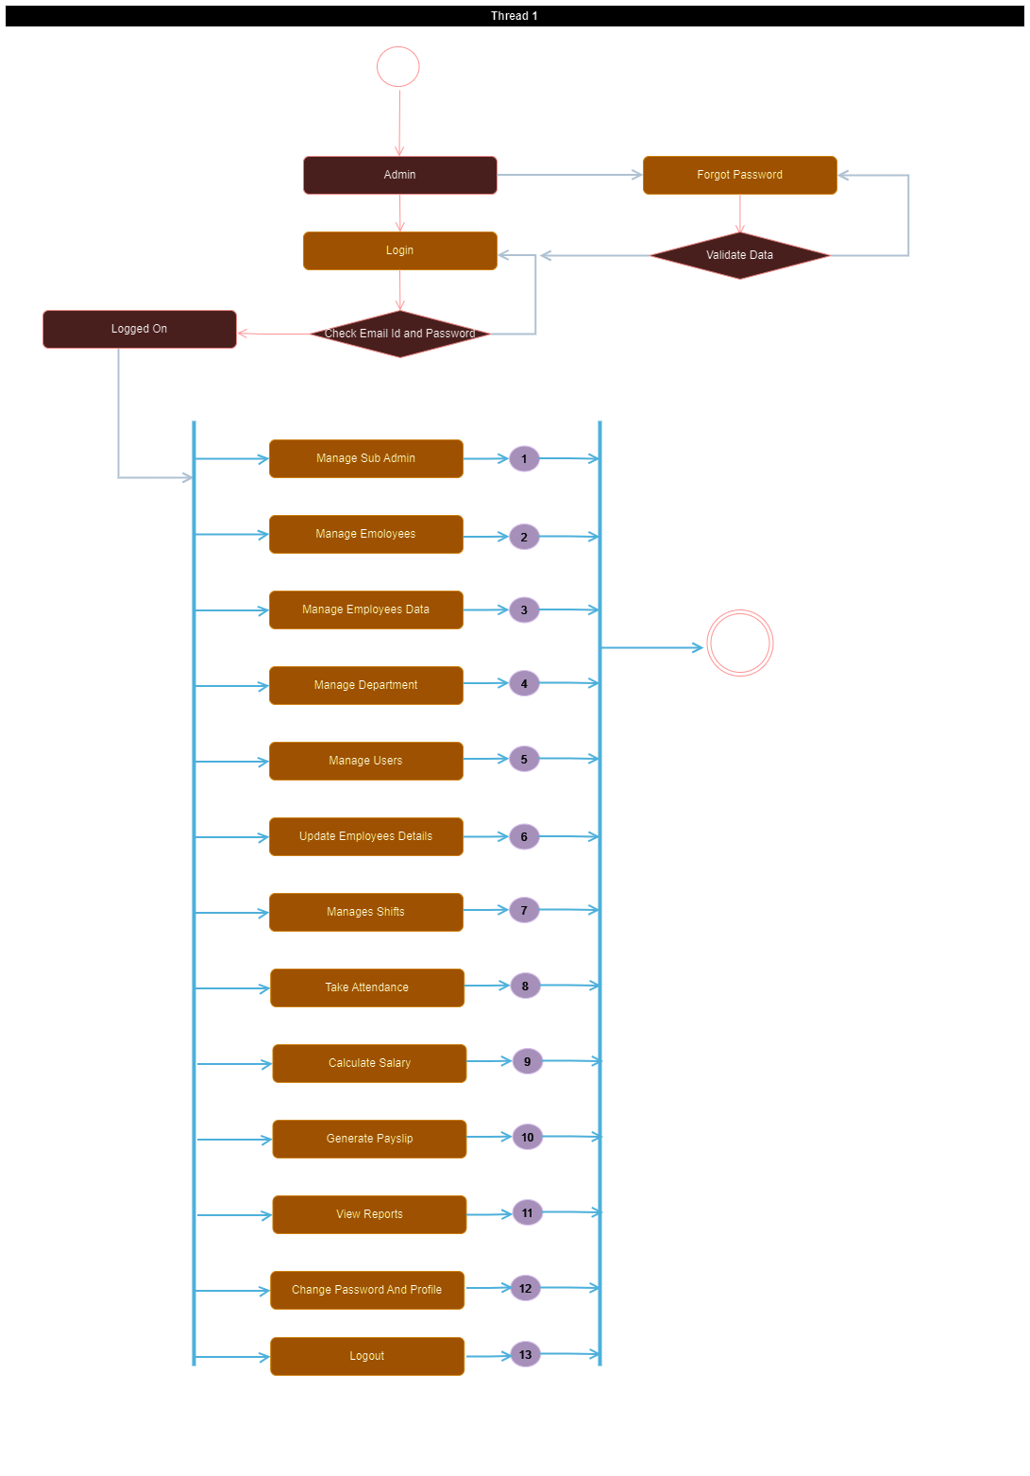

* **Activity Diagram for Employee:**

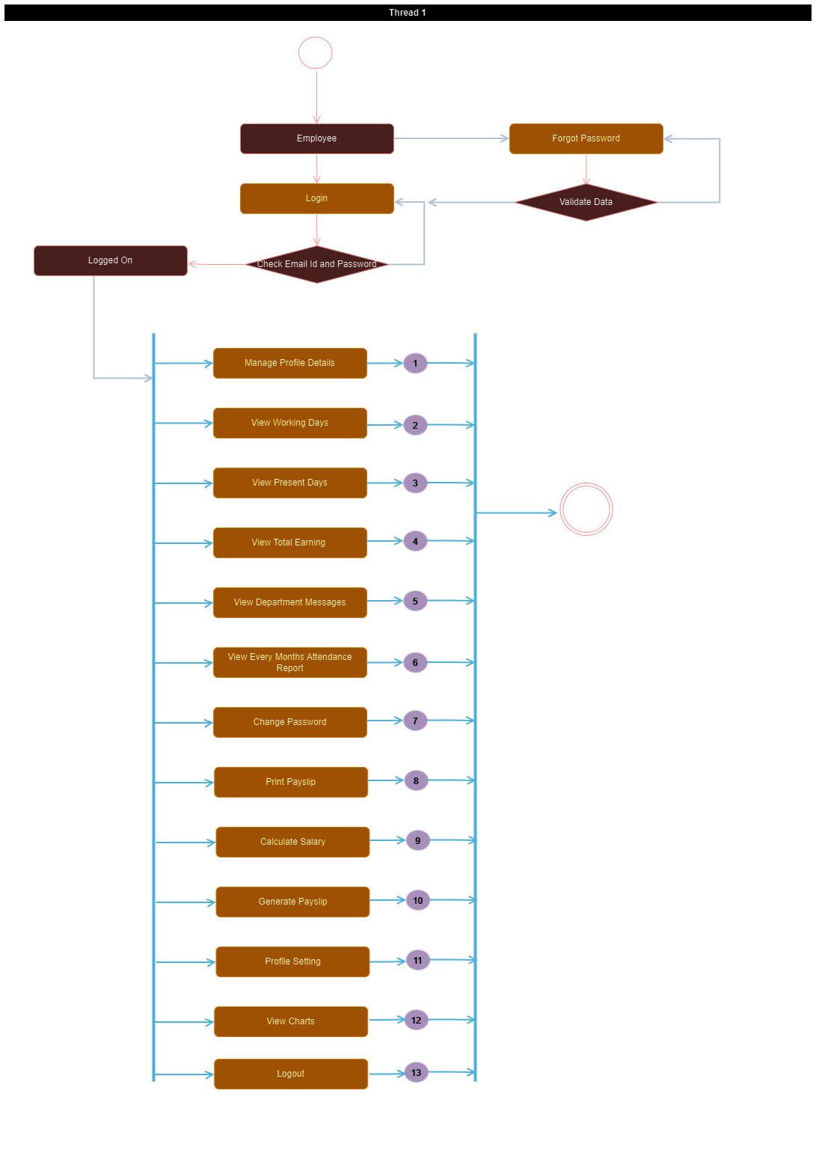

**7**

Chapter

**System Diagram**

|  |  |
| --- | --- |
| 7.1 | Navigation Map |
| 7.2 | Database Diagram |
| 7.3 | Table Structure |
| 7.4 | Screen Layout |

7.1 Navigation Map

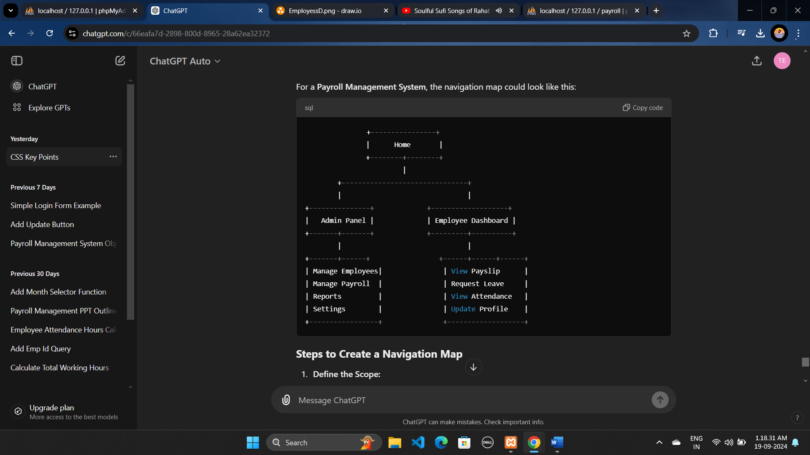

**Benefits of a Navigation Map**

1. **Clarity in Structure:**
   * Provides a clear and organized view of how the system is structured, making it easier for developers and designers to build and refine the system.
2. **Improved User Experience:**
   * Helps in planning user navigation paths, ensuring ease of use and logical flow for end-users.
3. **Development Roadmap:**
   * Acts as a guide for developers to understand the scope and features that need to be implemented.
4. **Content Planning:**
   * Helps in organizing content and identifying areas that need more detail or functionality.

**Conclusion**

A **Navigation Map** is an essential tool for designing and understanding the structure of a system or website. It visually represents how users will navigate through the different sections, making it easier to plan, develop, and ensure an intuitive user experience.

7.2 Database Diagram

A **Database Diagram** (also known as an Entity Relationship Diagram or ERD) visually represents the structure of a database. It shows the relationships between different tables (entities), as well as the attributes (fields) and key constraints of those tables. It’s essential for database design and development, providing a clear overview of how data is organized and related.

* Admin Side

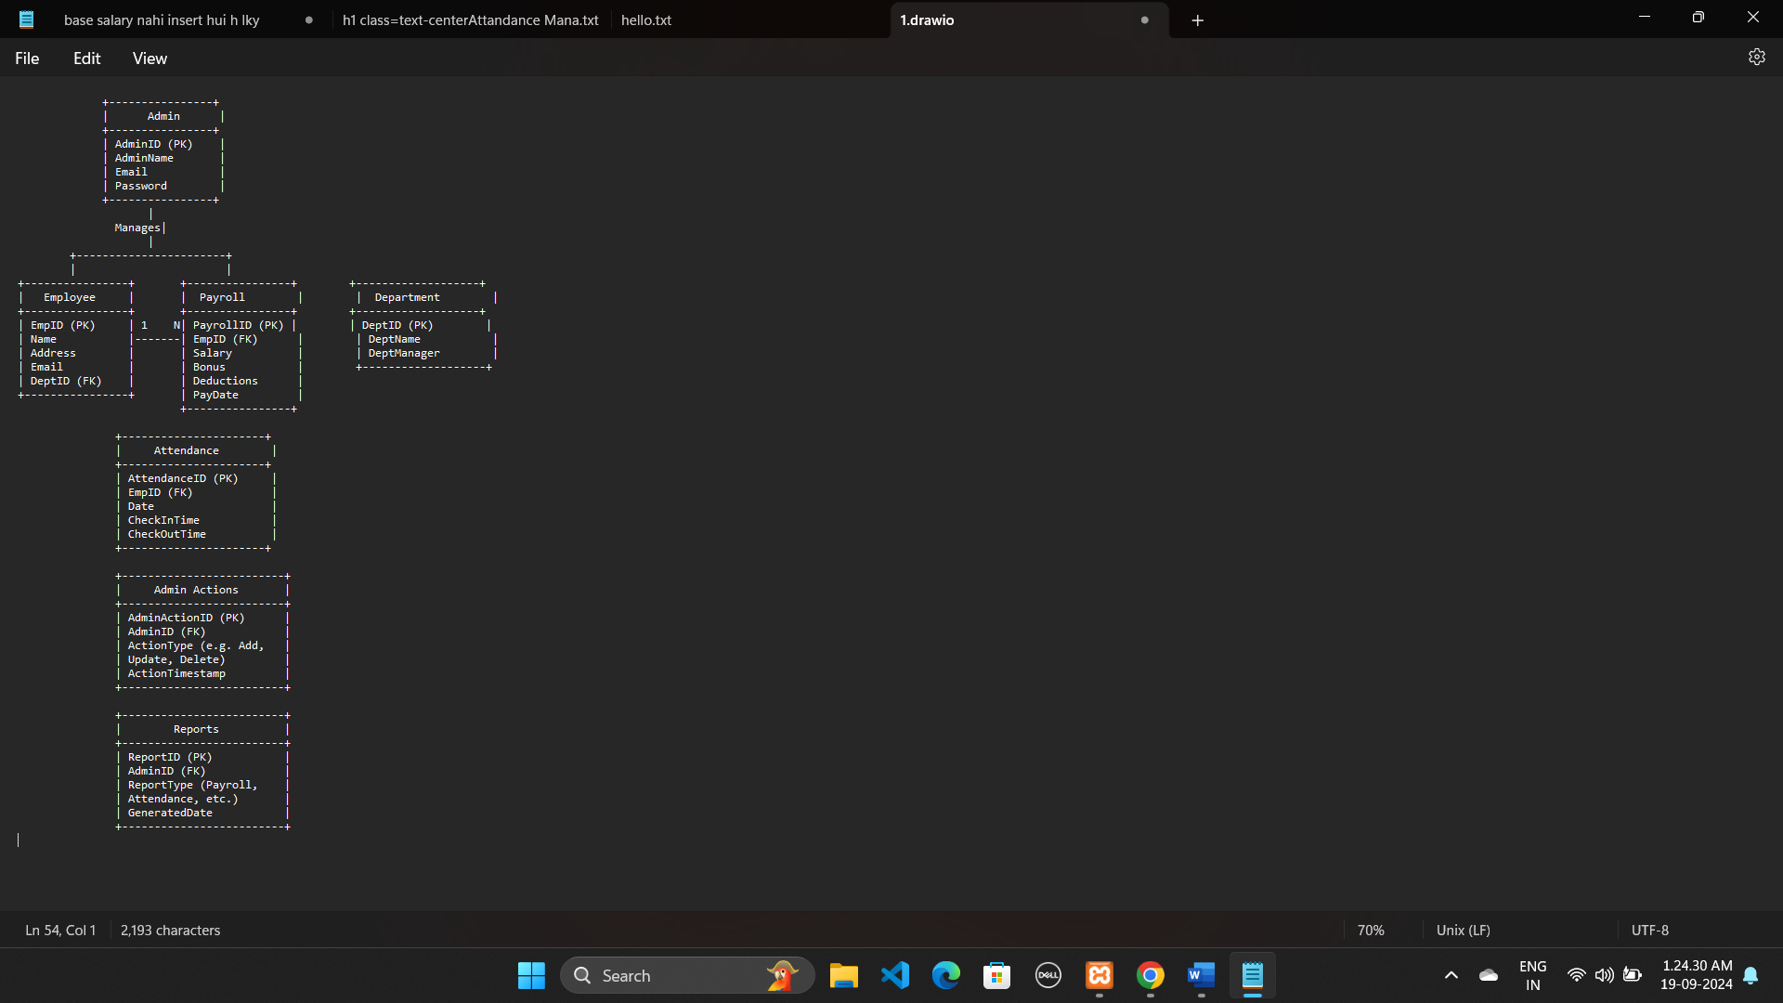

* Employee Side

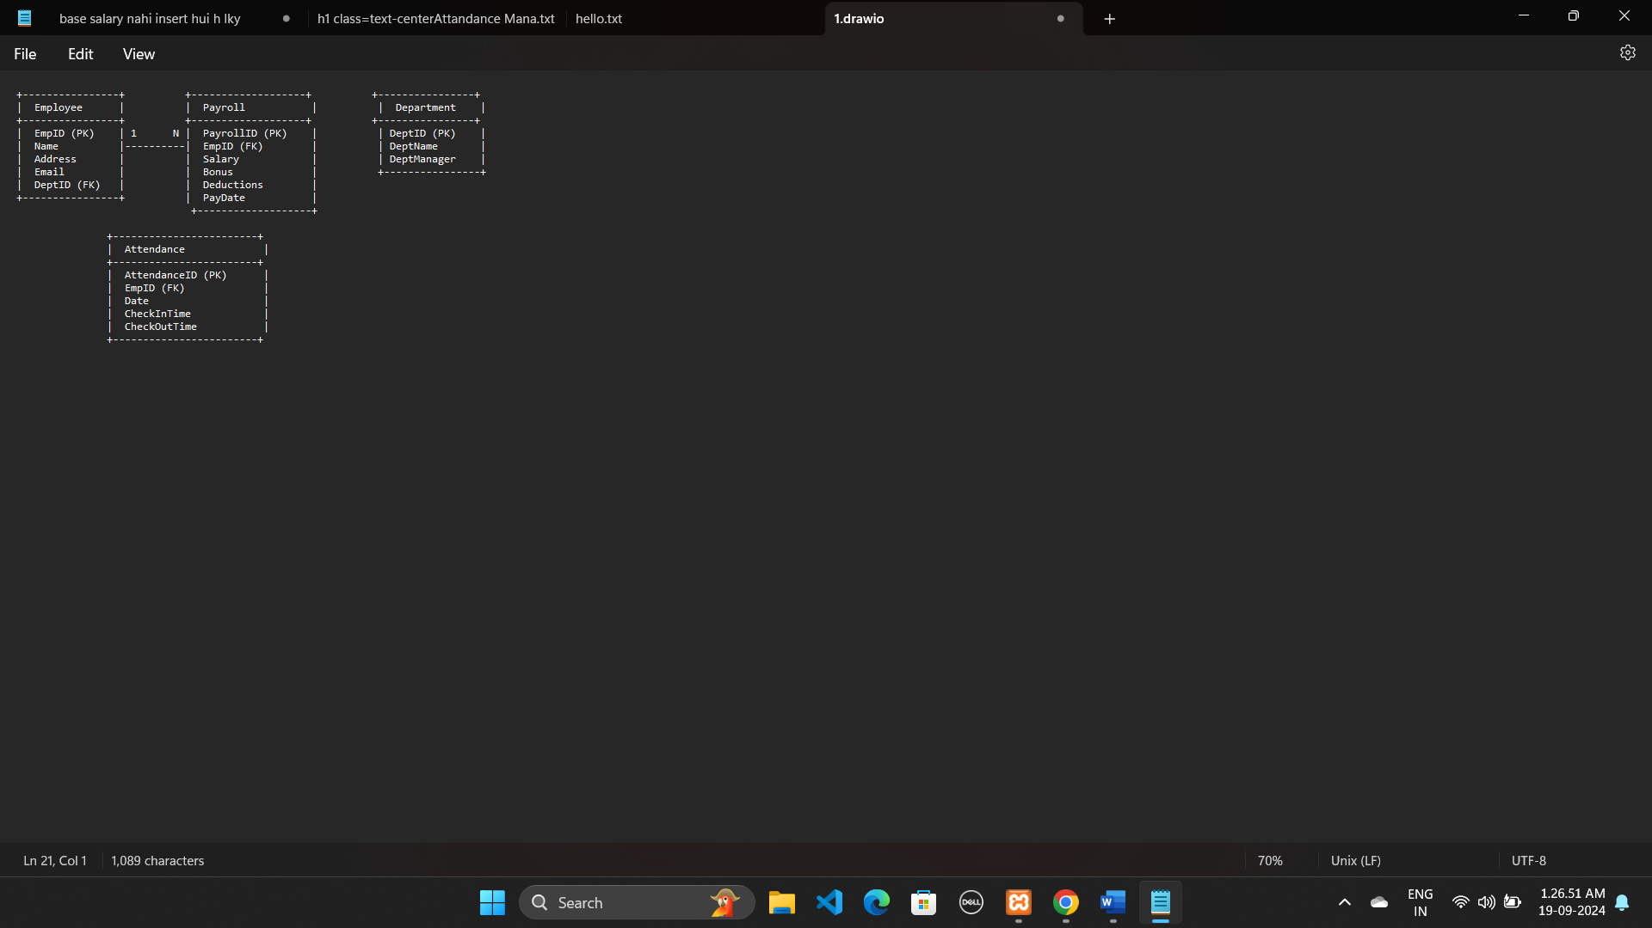

7.3 Table Structure

Here's the **table structure** for the **Payroll Management System** database, including both **Admin** and **Employee** sides. This structure outlines the fields, data types, and constraints for each table in the system.

**Table Name:** tbladmin  
**Use:** It is used to store the information of Admin.

|  |  |  |
| --- | --- | --- |
| Field Name | Data Type | Description |
| Id | Int(11) | Unique identifier for admin |
| First_Name | Text | First Name of the admin |
| Last_Name | Text | Last Name of the admin |
| Email | Text | Email address of admin |
| Department | Text | Department of admin |
| Shit_Name | Text | Shift name of admin |
| Phone_Number | Text | Phone number of admin |
| Address | Text | Address of admin residence |
| Date_Of_Birth | Date | Date of birth of admin |
| Date_Of_Joining | Date | Date of joining |
| Gender | Text | Gender of admin |
| Username | Text | Username of admin |
| Password | Text | Pass code to login into the system |
| AdminProfile_Picture | Varchar(20) | Profile pictire of admin |

**Table Name :** tblEmployee

**Use :** It is used to store the information of Employee.

|  |  |  |
| --- | --- | --- |
| Field Name | Data Type | Description |
| Id | Int(11) | Unique identifier for Employee |
| First_Name | Text | First Name of the Employee |
| Last_Name | Text | Last Name of the Employee |
| Email | Text | Email address of Employee |
| Department | Text | Department of Employee |
| Shit_Name | Text | Shift name of Employee |
| Phone_Number | Text | Phone number of Employee |
| Address | Text | Address of Employee residence |
| Date_Of_Birth | Date | Date of birth of Employee |
| Date_Of_Joining | Date | Date of joining |
| Gender | Text | Gender of Employee |
| Username | Text | Username of Employee |
| Password | Text | Pass code to login into the system |
| Employee Profile_Picture | Varchar(20) | Profile pictire of Employee |

**Table Name :** tblDepartment

**Use :** It is used to store the information of Department.

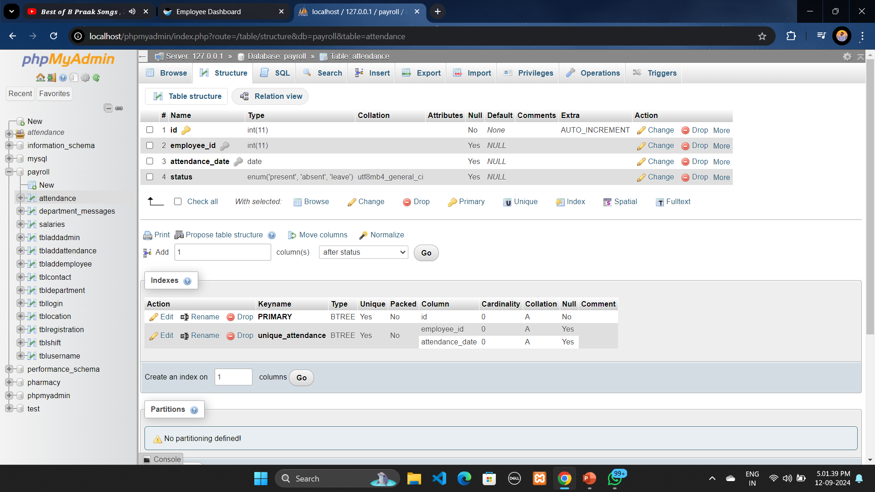

**Table Name :** tblMessage

**Use :** It is used to store the information of Admin Passed Messages For Department Employees.

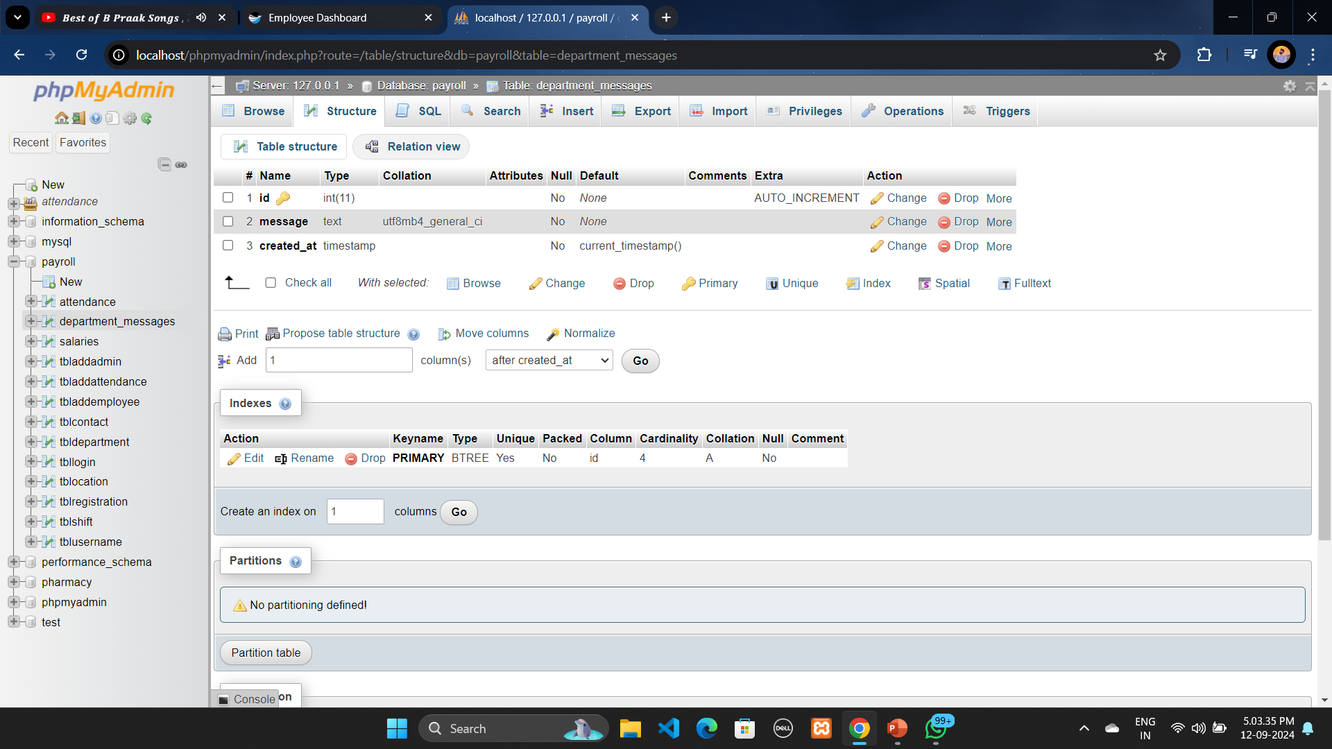

**Table Name :** tblSalaries

**Use :** It is used to store the information of Salaries.

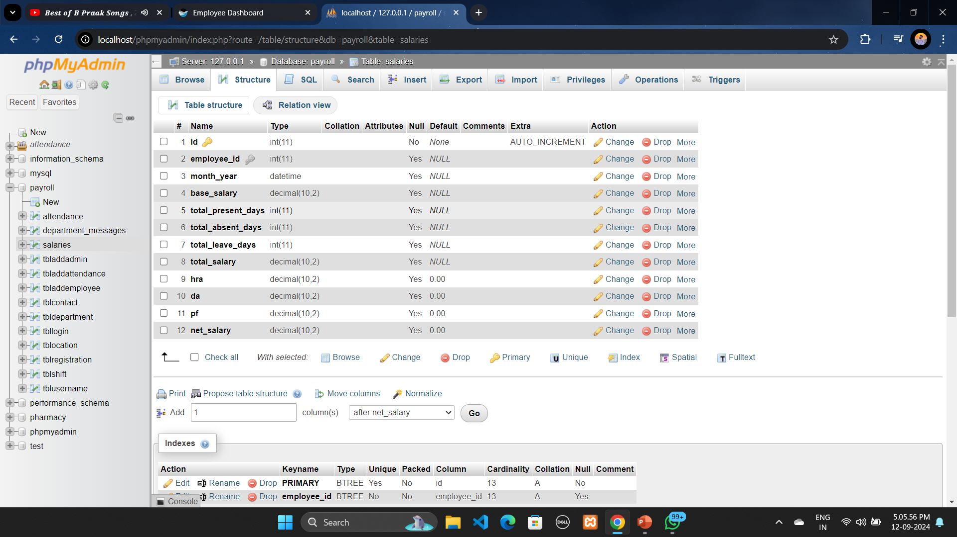

**Table Name :** tblAttendance

**Use :** It is used to store the information of Attendance.

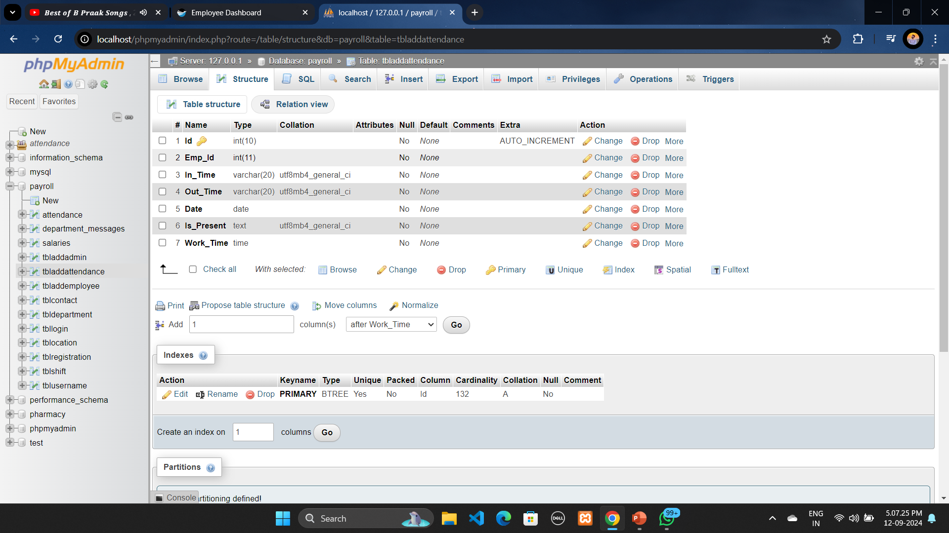

**Table Name :** tblShift

**Use :** It is used to store the information of Shifts.

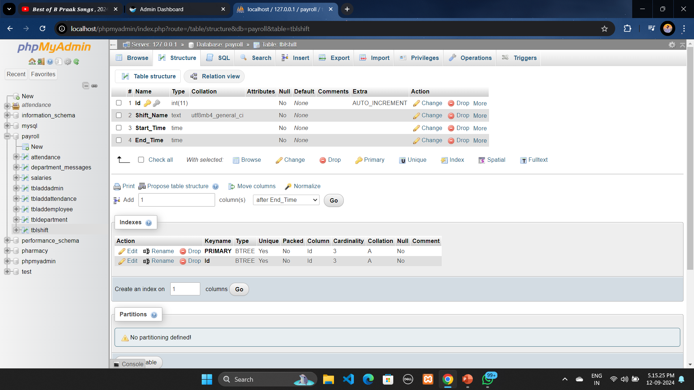

7.4 Screen Layouts

* **Login Page : Admin**

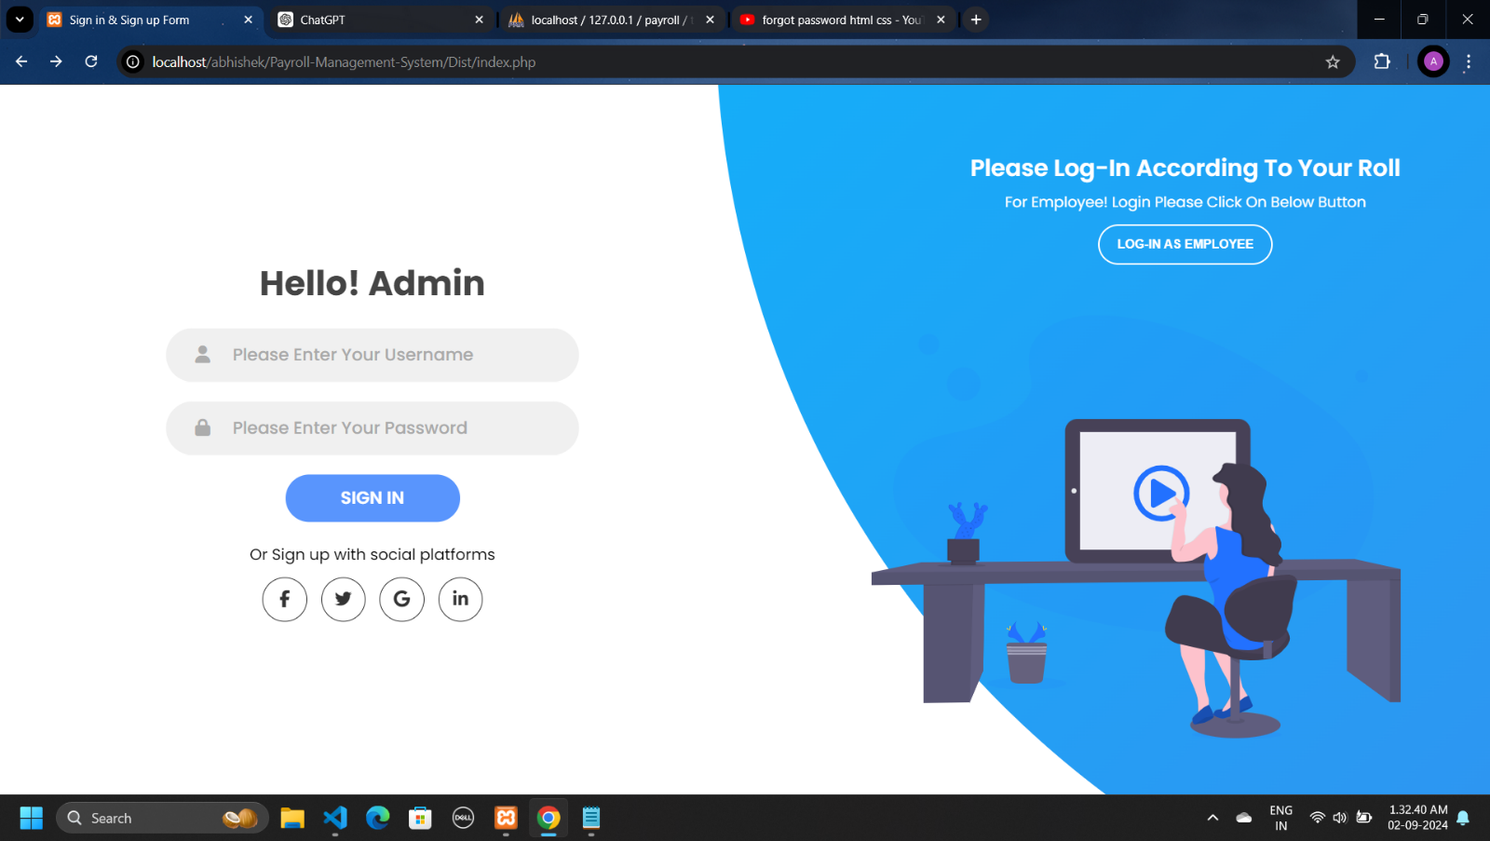

* In this page admin can login in to own website for authentication check.
* In any situation admin forgot the password the can get password on registered mail it will display on next page.
* **Login Page : Employee**

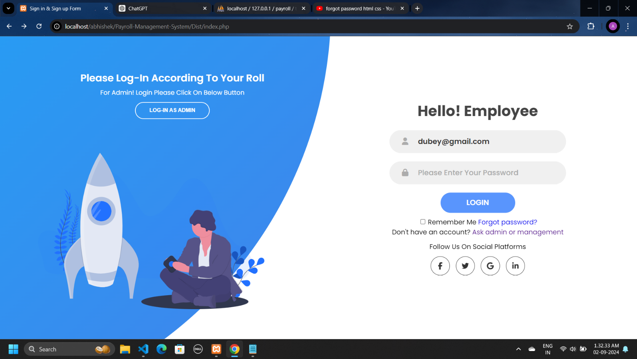

* In this page employee can login in to own website for authentication check.
* In any situation admin forgot the password the can get password on registered mail it will display on next page.
* **Registration Page : Employee**

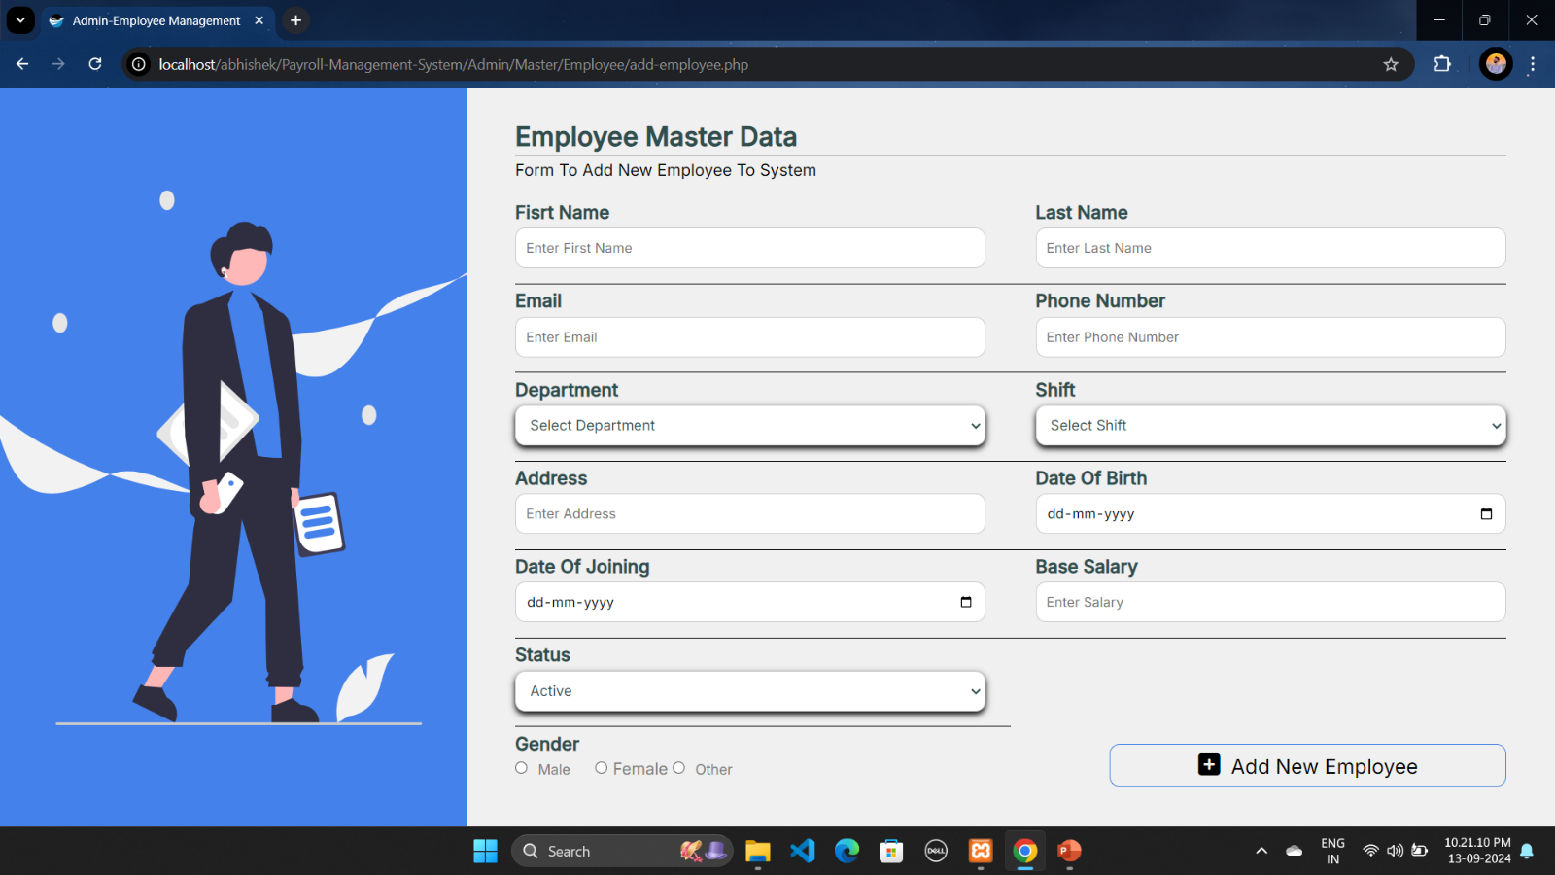

* In this page admin can enter employees basic details.
* After adding all details he can store the all data in the database system bu clicking on the add new employee button.\
* And all data can stored in database.
* Employee Information Change Form (Admin Side)

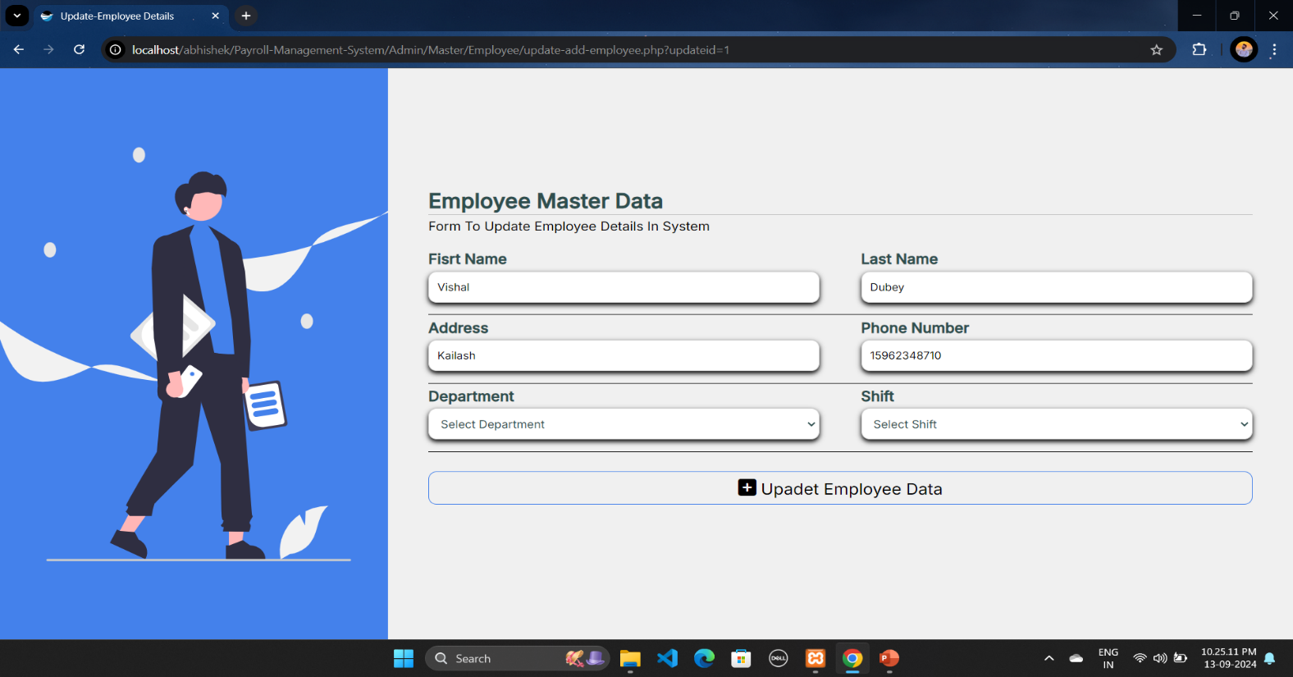

* In this page admin can update details of employees if there is any mistake in database
* After entering correct information admin can save this
* Admin Dashboard

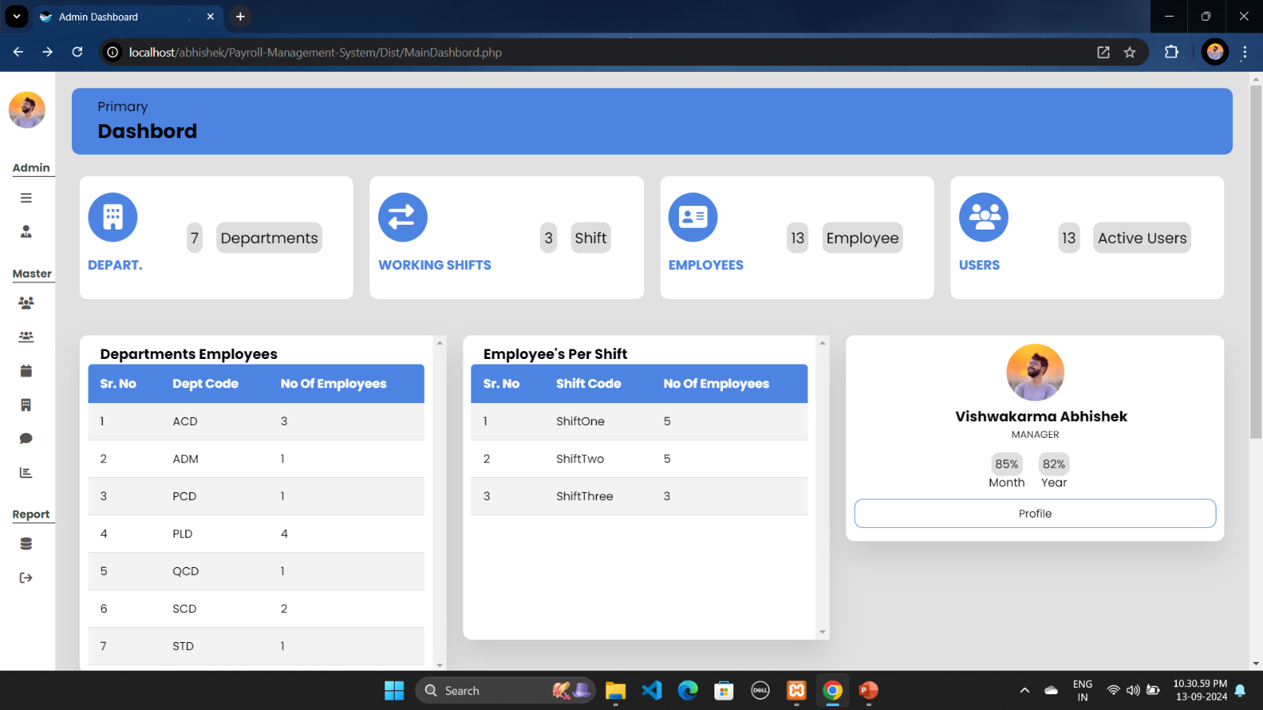

* In this page you can have a look on admin dashboard page where he can manages all things.
* Employee Dashboard

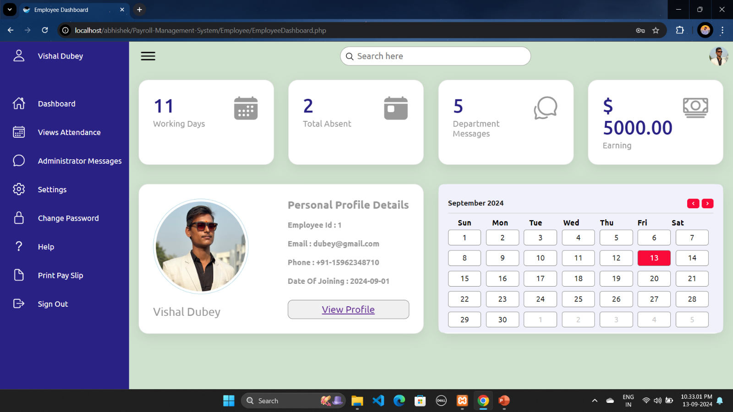

* In this page you can have a look on Employee dashboard page where he can manages all things.
* **Displaye Page : Admin Side**

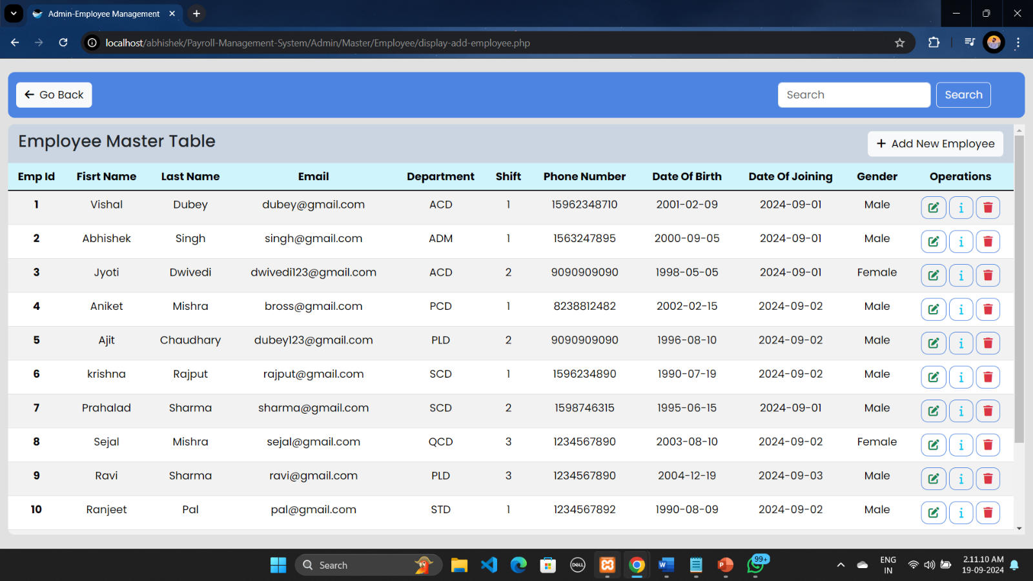

* In this page you can see all workings employees list.
* And you can perform action according to need.
* Update , delete and info buttons are given here.
* Forgot Password Page

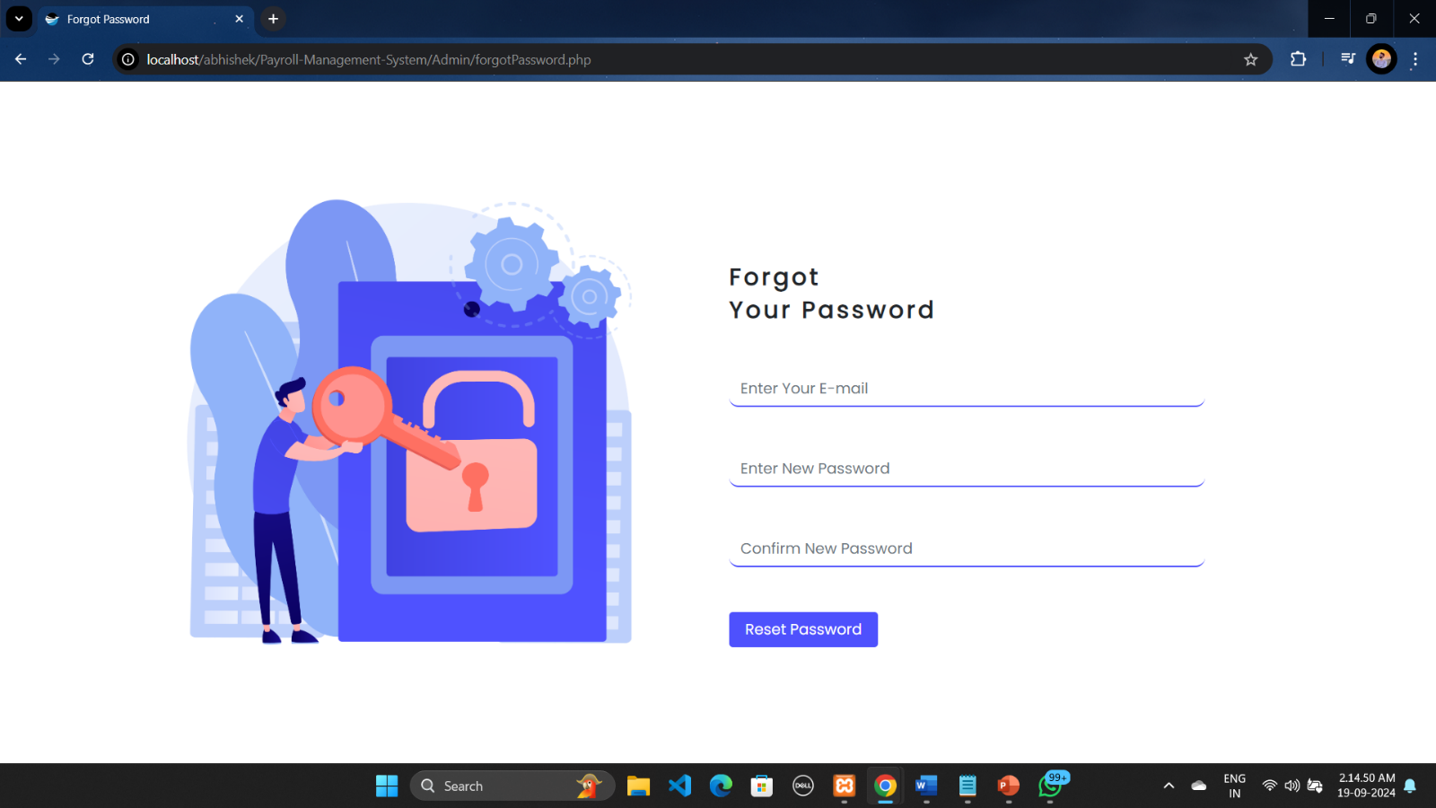

* In this page you Employee/Admin can change there password if they are forgot it
* By validating there email Id they can able to change password
* Profile Page

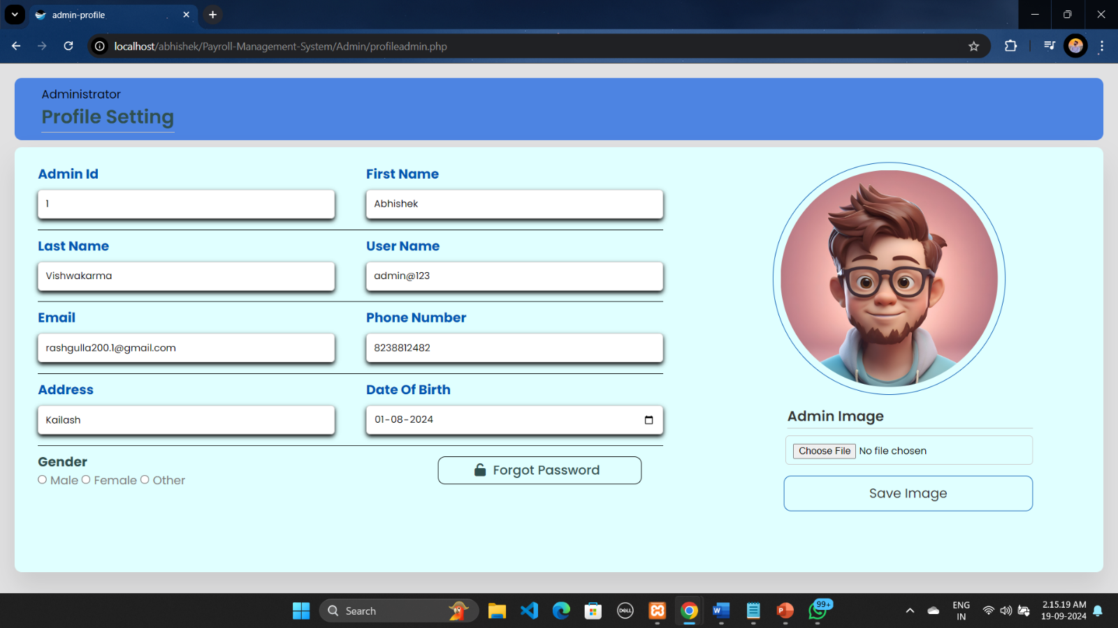

* In this page you can see your profile information.

**8**

Chapter

**System Testing**

|  |  |
| --- | --- |
| 8.1 | Testing Introduction |
| 8.2 | Test Case |
|  |  |
|  |  |

8.1 Testing Introduction

**Software testing** is a critical phase in the software development lifecycle (SDLC) that ensures the quality, functionality, and reliability of a system before it is deployed to users. It involves executing software with the intent of identifying any bugs, defects, or gaps in requirements, and ensuring that the system meets its intended purpose.

Testing verifies that the developed software product aligns with the original requirements and specifications while ensuring that it performs efficiently under various conditions. The process not only helps in detecting defects but also ensures that the software delivers a seamless user experience.

**Importance of Testing:**

* **Error Detection: Helps identify defects in the software early in the development cycle, reducing costs for fixing bugs later.**
* **Improves Software Quality: Ensures that the product is bug-free and functions smoothly, leading to higher user satisfaction.**
* **Ensures Reliability and Performance: Testing validates that the software can handle real-world conditions, such as high user load or unexpected inputs.**
* **Compliance and Security: Testing ensures that the software meets industry standards, regulatory compliance, and is secure against vulnerabilities.**

**Conclusion**

**Testing is a vital part of software development that ensures the final product is robust, reliable, and meets user expectations. By identifying and addressing issues early, it reduces the likelihood of defects reaching the end-user, leading to a successful and well-functioning system.**

8.2 Test Case

1. **Data entry**: Test the data entry fields to make sure they are properly formatted and validated. For example, the phone no field should only accept numeric values and 10-digit number and hire date field should only accept date values.
2. **Calculation**: Test the payroll calculations to make sure they are accurate. For example, the system should correctly calculate all employee salary accurately.
3. **Security:** Test the security of the payroll system to make sure it is protected form unauthorized access. For example, the system should require users to authenticate themselves before they can access sensitive data.
4. **Reports:** Test the payroll reports to make sure they are accurate and easy to read. For example, the system should generate a report that list all employees and their pay stubs for a given period.

**9**

Chapter

**System Limitations And Future Enhancement**

Even the most advanced systems have certain limitations. In the context of a **Payroll Management System**, there are several potential constraints and areas that could affect its overall functionality or performance.

1. **Limited Scalability**:
   * The system may struggle to handle a rapidly growing number of employees or departments without significant performance degradation. If not designed for scale, the system might experience slowdowns or inefficiencies as the business expands.
2. **Customization Restrictions**:
   * The system might not offer extensive customization options for different payroll rules, tax structures, or organizational policies. This can limit its flexibility for businesses with unique payroll needs or multi-national payroll processing.
3. **Dependency on Internet Connectivity**:
   * For cloud-based or online payroll systems, a stable internet connection is required. Any disruption in connectivity can affect access to critical payroll functions and data.
4. **Limited Integration with Other Systems**:
   * If the system does not integrate seamlessly with other essential systems like HR software, accounting systems, or time tracking tools, it could result in inefficiencies or data silos.
5. **Data Security Concerns**:
   * Payroll systems deal with sensitive employee data such as salary details, bank account information, and personal identifiers. If the system lacks robust encryption and security measures, it may be vulnerable to data breaches or unauthorized access.
6. **Manual Processes for Complex Payroll**:
   * In cases where the payroll process is highly complex (e.g., employees working in multiple states or countries with varying tax laws), manual intervention may be required, which can introduce errors and inefficiencies.
7. **Compliance with Local Laws**:
   * The system might not automatically update to comply with changes in tax laws, labor regulations, or statutory reporting requirements, which could result in legal issues or penalties for the organization.

**Future Enhancements**

There are several ways a Payroll Management System can be improved to address existing limitations and provide added value to users:

1. **Enhanced Scalability and Performance**:
   * Future versions of the system can be designed with advanced database structures and cloud infrastructure to handle increasing data loads and employee records without performance bottlenecks.
2. **Better Customization and Flexibility**:
   * Introducing more customizable templates for payroll, tax regulations, and employee benefits will allow businesses to adapt the system to their unique requirements, including different regions and industries.
3. **Advanced Integration Capabilities**:
   * Providing API support and integrations with popular HR, finance, and time tracking systems can create a seamless flow of data, reducing redundancies and manual data entry.
4. **Improved Security Features**:
   * Future iterations should incorporate stronger encryption, multi-factor authentication (MFA), and enhanced data security measures to protect sensitive employee information.
5. **Mobile and Remote Access**:
   * Adding robust mobile functionality will allow employees and admins to access payroll information, submit requests, and manage payroll tasks from anywhere. This could improve convenience and productivity, especially in remote work environments.
6. **Real-time Compliance Updates**:
   * Automatic updates for changes in tax laws, labor regulations, and other compliance requirements would minimize the need for manual updates and reduce the risk of non-compliance.
7. **AI-Driven Insights and Reporting**:
   * Artificial intelligence (AI) and machine learning could be leveraged to provide predictive analytics, salary forecasting, and error detection in payroll data. This would give administrators actionable insights to improve payroll efficiency.
8. **Self-Service Employee Portal**:
   * Enhancing the employee-side experience with self-service portals where employees can view their pay stubs, tax information, and attendance records in real time, request leaves, and submit updates to their personal details.
9. **Automated Payroll Calculations**:
   * Improve the automation of payroll calculations by incorporating more sophisticated algorithms that handle complex payroll scenarios like overtime, bonuses, and varying tax structures.
10. **Cloud-Based Backup and Disaster Recovery**:
    * Implementing cloud-based data backup and disaster recovery features will ensure that payroll data is always safe, recoverable, and accessible in case of technical failure or unforeseen events.

**10**

Chapter

**References**

|  |  |
| --- | --- |
| 10.1 | Bibliography |
| 10.2 | Webography |

10.1 **Bibliography**

All the needed information related to my project “**Payroll Management System”** was being clumped from the following sources:

* **Books:**
* **For PHP**
* PHP Manual
* PHP 5 Fast & Easy Web Development, Julie C. Meloni, 2nd Ed, 2002.

10.1 **Bibliography**

* **Sites** [**URL:-**](URL:-)
* **For PHP**
* www.php.net
* http://www.w3schools.com/php/
* **For MySQL**
* http://dev.mysql.com/doc
* **For JQuery and CSS**
* http://jquery.com/
* http://css-tricks.com/
* http://cssglobe.com/